Visualising UKCEH Land Cover Classes using GIS software
To display the 21-class raster products (specifically the 10m, 25m and 1km dominant target class products) QGIS and Arc symbology files are provided alongside the respective data product (QGIS: lcm_raster.qml, lcm_raster_cb_friendly.qml, Arc: LCM2017-2024_raster.lyr, LCM2017-2024_raster_cb_friendly.lyr). Vector symbology files (QGIS: lcm_vector.qml, lcm_vector_cb_friendly.qml, Arc: LCM2017-2024_parcel.lyr) are also provided for the vector data set.
No colour palettes are currently provided for the 1km aggregate class products, or the 1km percentage products.
The Land Cover Map rasters are multiband
- The 20m (LCM2017-LCM2019) and 10m (LCM2020 onwards) raster datasets have two bands. Band 1 is the UKCEH Land Cover Class identifier; band 2 is an indicator of classification confidence.
- The 25m datasets have three bands. Band 1 is the dominant UKCEH Land Cover Class identifier; bands 2 and 3 are indicators of classification confidence.
This document is a short guide for using the most commonly used GIS applications to visualise the Land Cover Class data contained in band 1.
Visualising the data using QGIS
Visualising the data using ArcGIS Desktop
Visualising the data using ArcGIS Pro
For a full description of the data, please refer to the product documentation

Visualising the data using QGIS
Add the file to your project.
The data will be presented and will appear in the layers panel:
Double-click on the layer name in the layers panel.
The layer properties, box will be displayed, choose Symbology from the left-hand menu bar [A]  In the render type box, choose Palleted/unique values [B]  In the band box, choose Band 1 [C] | A  B  C
Click the style, button and choose Load style from the menu.
Browse to the appropriate qml file that accompanies this document, select it and click open.
Click OK and the map will be redrawn with the correct classification.

Visualising the data using ArcGIS Desktop
In the catalogue window, browse to the folder in which the data is stored.  Expand the file to display the raster's bands. | 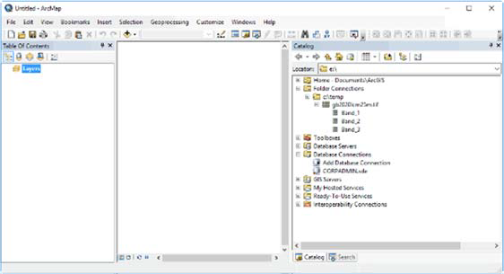
Drag band_1 into the Table of contents window.  Double-click on the layer name in the table of contents. The layer properties box will be displayed. | 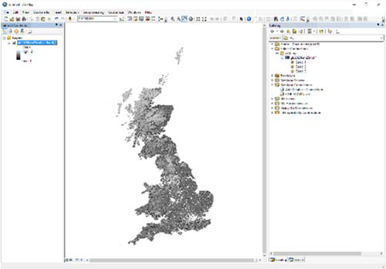
In the layer properties box, select the symbology tab [A].  Choose Unique Values as the symbology type [B] (if prompted to calculate the values, click YES)  Click the import button [C] and load in the appropriate layer file provided with these instructions. | 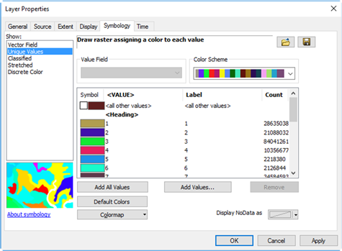  A  B  C
Click OK and the map will be redrawn with the correct classification.

Visualising the data using ArcGIS Pro
In your ArcGIS Pro project, open the catalogue window  Browse to the folder in which the data is stored.  Expand the file to display the raster's bands. | 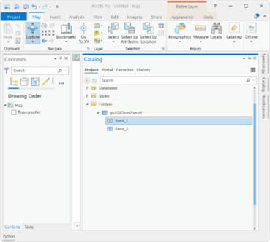
Drag band_1 into the Table of contents window.  Double-click on the layer name in the table of contents. The layer properties box will be displayed. | 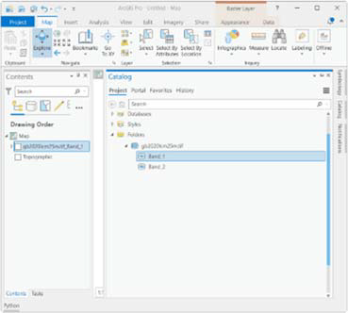
Select the layer in the Contents window and open the symbology properties (Raster Layer > Symbology)  In the primary symbology options choose Unique values. (If prompted to build an attribute table, click Yes) | 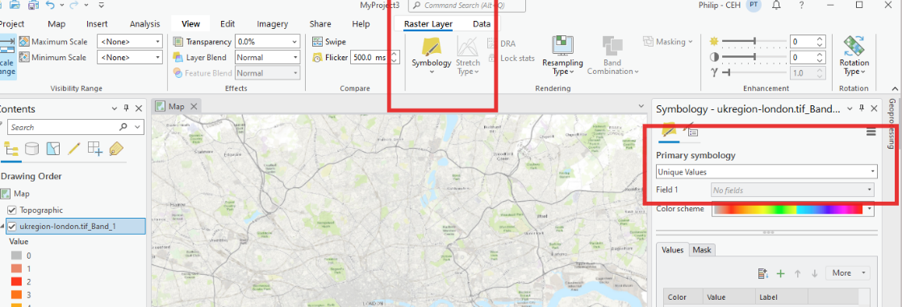
Click on the hamburger menu in the symbology panel and choose Import from layer file.  Load in the appropriate layer file provided with these instructions. | 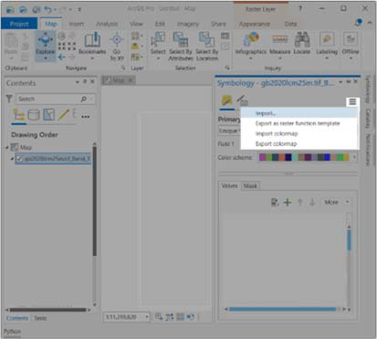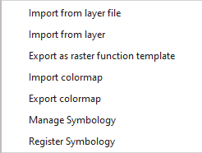
The map will be redrawn with the correct classification

